**CyPlus 2020 – India Innovation challenge**

|  |  |
| --- | --- |
| Team Name | Office Bois |
| Number of Participants | 4 |
| Participant Names (Initials) | 1. Jeetendra Ashok (PAJE) 2. Bragadeesh Viswanathan (BRVI) 3. Rakshith M B (RMBK) 4. Dheeraj Kamath (DDKA) |
| What do you want to call the solution? | Smart Workspace |
| How is this innovation useful? | Improve the experience of the ordinary office goer by connecting the real world with the digital world |
| What work output will you present? Check all applicable | Simulation  Hardware Demo  Software Demo |
| Have you presented this idea in other forums (CITEC, Innovation forum, and so on)? | CITEC |

**Abstract**

While there have been significant advancements in the space of the smart homes and cars, the office workspace has pretty much been the same over the last 15 years. We plan to showcase innovations that would greatly improve the experience of the ordinary office goer by connecting the real world with the digital world.

Innovations in user experience:

1. **Entry, exit and real-time location detection** – This would help us to accurately monitor the number of people in the office. Based on where this is deployed, it can be used to predict free parking spaces, predict empty office cubicles, food and beverage requirements among others. Real-time location can be used to navigate the user to find their peer or to a meeting room they are looking for.
2. **Surrounding customization** – A Harvard study showed that employees in a properly ventilated green workspace performed 61% better on cognitive tasks when compared with standard office conditions. The users will be able to customize lighting and air temperature as per their choice. The system will automatically adjust lighting and temperature when the user enters his cubicle. It will also continuously monitor the quality of air and notify if the quality drops.
3. **Customized display** – Each cubicle will have a separate display which will showcase constant notifications such as user meeting schedules, reminders, temperature, air quality among others (time, date etc.). This will help the user get curated information that will jump start their day and assist them throughout.
4. **Equipment monitoring** – With shared equipment, it’s easy to lose track of where it is and who has it. The equipment in each workspace will be tagged and connected to pressure monitors to determine if the equipment is present and notify if someone moves the equipment.

To exhibit these features, we will use the following sensors connected to a PSoC® 6 device:

1. **Equipment monitoring** - Infineon DPS310 Shield2Go and MFRC522 RFID Reader
2. **Air quality measuring** - CO2 Sensor Infineon XENSIV™ PAS210 / CCS811
3. **Real-time location detection** – Infineon 24 GHz Radar
4. **Temperature and Humidity measuring** - DHT11 Sensor

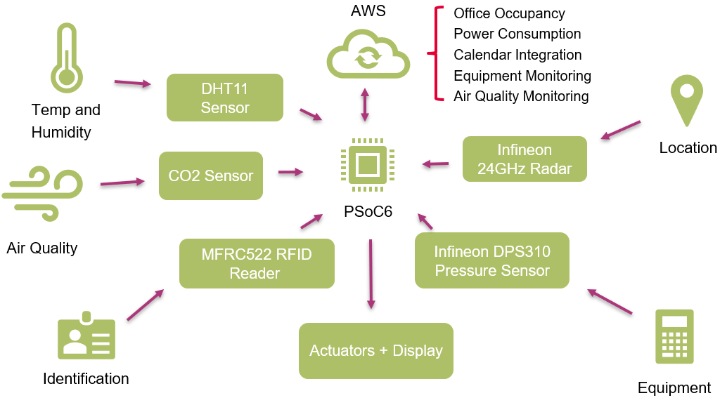

**System Block Diagram**